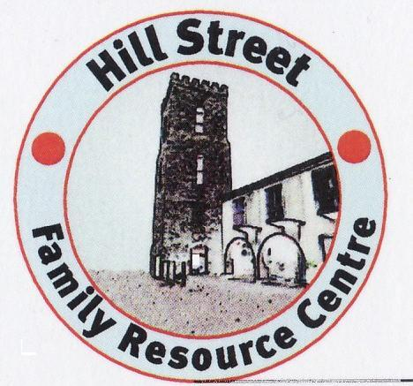 Hill Street Family Resource Centre
Hill Street Playground, Hill Street, Dublin 1 Tel/Fax: 01-874 6810
Email: childdevelopment@hillstreetfrc.ie
Incredible years parenting programme for parents who wish to raise happy confident children.
None of us are born knowing how to parent, but we can all learn

Incredible Years Programme was designed to help children develop social and emotional skills. It works with parents to deliver these skills to their children; it also benefits parents of children who have challenging behaviour.
Over the course of the 14 weeks you will learn how to:
- Build your child’s self-esteem  - Build a positive relationship between you and your child.  - Avoid the criticism trap  - Encourage your child  - Know the difference between bribes & rewards | - Support your child socially, emotionally & academically  - Teach your child about family responsibilities  - Give more effective direction  - Be consistent and follow through  - Use Time-Out correctly

Starting Tuesday 19th January 9.30am-11.45am (14 weeks)
Childcare places are available on request
To register please contact: Connie or Bernie on 01-8746810
Course contribution per session is €2, or €5 with childcare

